THE ROMAN REPUBLIC

Rome established a tripartite government. This type of government has three branches: executive, legislative and judicial. The executive branch enforces a country’s laws. The legislative branch makes the laws. And the judicial branch interprets the laws in court.

Executive branch.

Rome had two officials called consuls. Like kings, they commanded the army and directed the government. However, their power was limited. A consul’s term was only one year long. The same person could not be elected consul again for ten years. Also, one consul could always overrule, or veto, the other’s decision.
In times of crisis, the Republic could appoint a dictator – a leader who had absolute power to make laws and command the army. A dictator’s power lasted for only six months. Dictators were chosen by the consuls and elected by the Senate.

Legislative branch.

The Legislative branch of government included the Senate and the Assemblies. The Senate was the most powerful part of the government of the Republic. Its 300 members were chosen from the upper class of Roman society. Later, plebeians were allowed in the Senate. In the Senate, Rome’s most influential citizens debated and decided such important issues as Rome’s finances, foreign affairs and handled the daily problems of government. They also advised the consuls on their decisions.
The Assemblies were mainly made up of plebeians. Their representatives protected the rights of plebeians. In these Assemblies, the tribunes – or government officials who protected the rights of plebeians - were elected and laws were made for the common people.

Judicial branch.

The judicial branch consisted of eight judges, or praetors, who served for one year. They oversaw the courts and governed the provinces.

COMPARING REPUBLICAN GOVERNMENTS
 | ROME | COLOMBIA
Executive | Two consuls elected by the Assembly for one year – chief executives of the government and commanders in- chief of the army | A president, elected by the army for four years – chief executive of the government and commander in- chief of the army.
Legislative | * Senate of 300 members, chosen from aristocracy for life – controls foreign and financial policies, advises consuls.  * Centuriate Assembly, all citizen- soldiers are members for life – selects consuls and makes laws  * Tribal Assembly, citizens grouped according to where they live are members for life – elects tribunes and makes laws. | The legislative branch is divided into a Congress (within the Congress we find the Senate and the Chamber of Representatives) and departmental assemblies and Municipal councils.
Judicial | Praetors, eight judges chosen for one year by Centuriate Assembly – two oversee civil and criminal courts (the other govern provinces) | The judicial branch in Colombia is divided in: high courts (Supreme Court of Justice, Constitutional Court, State Council and Judicial Superior Court) and the General prosecutor of the Nation.
Legal Code | Twelve Tables – a list of rules that were the basis of Roman legal system | Colombian Political Constitution of 1991- basic law of Colombia.
Citizenship | All adult male landowners | All native born or naturalized adults

Question 1. How was the Roman Republic organized? Explain the functions of each branch.

Question 2. Define the following words, using the information above:
- consul
- Senate
- Assemblies
- Praetor

Question 3. Using the chart “Comparing Republican Governments”, find one similarity and two differences between the governments of Ancient Rome and Colombia today.

THE REPUBLIC EXPANDS
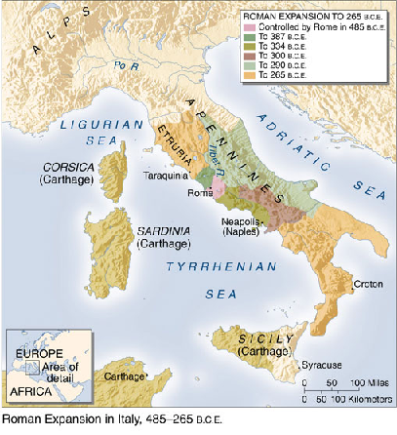

For hundreds of years after the founding of the Republic, Rome expanded its territories. By the 300´s B.C. (B.C.=Before Christ), the Romans dominated central Italy. They conquered the Etruscans to the North and the Greek city- states to the southeast. By 275 B.C. all of the Italian Peninsula was under Roman control.

Rome’s military success= 1. The army

Early in the Republic’s history, the army, which at first was made up mostly of patricians, began to require the service of plebeians. The sturdy farmer made an excellent soldier. He was loyal to his commander and strong enough to march 30 miles a day carrying 60 pounds of armor, weapons and supplies.

The strength of the Roman army lay in its superior discipline and organization. Roman troops used the same weapons as their enemies – swords, spears, daggers, bows and arrows, and stones. Yet while their opponents fought like a mob, in a disorganized way, the Romans adopted and improved upon the Greek phalanx – a close battle formation. The basic unit of the Roman army was the legion. A legion was made up of 3000 to 6000 foot soldiers and 100 or more cavalry – troops on horseback. This organization strengthened the determination and confidence of Roman soldiers.
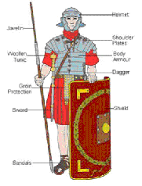
A Roman soldier

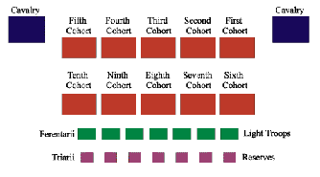
A typical Legion formation

Rome’s military success= 2. Allies

Despite the strength of its army, Rome could not have conquered Italy without the help of neighboring peoples. Rome made allies of some former enemies by giving them protection and, in some cases, Roman citizenship and self- government. In return, Rome gained new foreign soldiers for its armed forces. By 225 B.C. more than half of the Roman army was made up of allies. The Roman’s conquests in Italy gave them the soldiers they needed to expand further.

The Punic Wars

In 264 B.C., Rome and Carthage went to war. This was the beginning of the long struggle known as the Punic Wars. Between 264 and 146 B.C. Rome and Carthage fought three wars. The first, for control of Sicily and the Western Mediterranean, lasted 23 years (264- 241 B.C.). It ended with defeat of Carthage.
The Second Punic war (218- 201 B.C.) would begin when the Carthaginians, led by general Hannibal Barca, attacked Rome by land from the north. Winning
victory after victory, Hannibal’s army fought its way to the gates of Rome. Unable to capture Rome, mainly because they lacked supplies, Hannibal and his troops roamed Southern Italy for 15 years destroying everything in their path. The war would end when Romans devised a plan to attack the Carthage and Hannibal was forced to come back to his hometown. There the Carthaginian army would be defeated by the Roman army.

During the third Punic War (149- 146 B.C.), Rome laid siege to Carthage. In 146 B.C., the city was set afire and its 50000 inhabitants sold into slavery. Its territory was made a Roman province.

Rome’s victories in the Punic Wars gave it dominance over the Western Mediterranean. The Romans then went on to conquer the Eastern half. By about 70 B.C., Rome’s Mediterranean empire stretched from Anatolia in the east to Spain in the west. As you will see, such growth and power brought with it new difficulties.

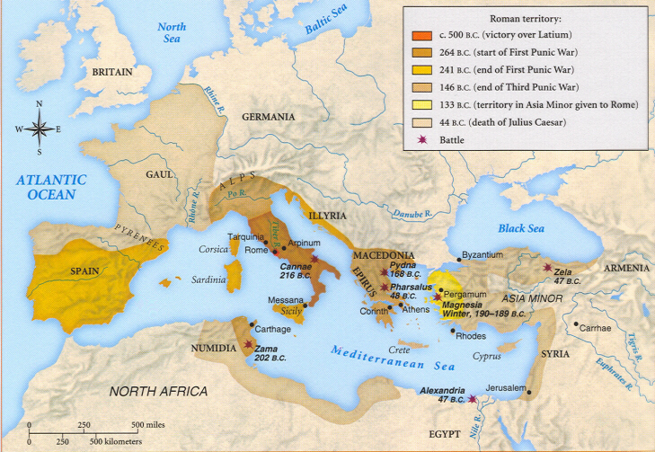
Roman expansion

Question 4. If you look at the map above, which territories were conquered by Rome between 264 and 241 B.C.? and between 241 and 146 B.C.? What about between 146 and 44 B.C.?

Question 5. Why was the roman army so successful at conquering different territories?

EFFECTS OF THE CONQUESTS: THE REPUBLIC COLLAPSES

While Rome’s wars were bringing new lands and power, economical and political problems surfaced at home. Some leaders tried to solve these problems, but the republic began to collapse.

Farm debts. The decline of the Republic began with a crisis in agriculture that brought disaster to thousands of small farmlands. Hannibal’s invasion of Italy had destroyed farms and farmland. Other farms had gone unattended while their owners went away to fight. Another difficulty came with the shipment of large amounts of grain and other farm products to Rome from conquered lands. This would create a surplus, so prices in Italy fell, and so did farmer’s income.

Sinking ever deeper into poverty and debt, many farmers sold themselves out to Romans who had grown rich during the war. These wealthy Romans, eager to invest in land, created huge estates. They found workers for their farms among the thousands of slaves taken prisoner during the war.

Unemployment. Many of the small farmers who had neither land nor jobs moved to the Roman cities to look for work. Few were able to find jobs there. They became part of the huge class of unemployed and resentful urban poor.

Social and political disorder. The Roman Republic in the second century B.C. was very different from the Rome that had defeated Carthage. Fear of Carthage had united Romans in the past. Now bitter conflicts divided the rich and poor, and violence often erupted. The Senate provided little leadership in these troubled times.
Many patricians became more concerned with keeping their power and wealth than with promoting the welfare of Rome. The common people, including thousands of landless farmers and unemployed urban poor, were ready to follow leaders who promised them food and entertainment.

Slave revolts. Another cause of unrest in the Republic was fear of the thousands of slaves in the population. In 73 B.C. the slave Spartacus proclaimed a war to free slaves in Italy. Some 90000 slaves ran away to join his revolt. For two years the slave army won many battles and destroyed many farms in southern Italy. The revolt ended when Spartacus was killed in battle and 6000 of his followers were put to death.

The rise of military leaders. During this period of unrest, it was easy for powerful and ambitious military leaders to gain support. Roman generals began to recruit soldiers from the jobless poor of the cities. Before this time, only men who owned property could be Roman soldiers. They had served in the army out of loyalty to Rome. Landless city people, on the other had, volunteered for service because these generals had promised them money, loot form conquered people, and land when the fighting was over. These soldiers felt loyalty to these generals rather than to the government.
It was now possible for a military leader supported by his own troops to take over the government by force. The problem now was who would take control. During the next few years, Rome would be involved in a series of civil wars which involved some generals who wanted to take control of government. Eventually, only one would take control of government: Julius Caesar.

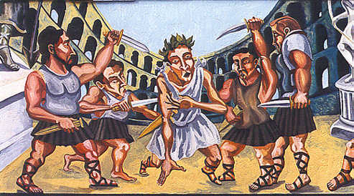Many Generals fought for control of government

Question 6. Explain how each of the following factors contributed to the collapse of the Roman Republic:
- The Conquests in the Mediterranean
- Farm debts
- Unemployment
- Social and political disorder
- Slave revolts
- Rise of military leaders

